QUICKLOAN GOVERNANCE REVIEW CARD

Section | Issue / Definition | Impact | Suggested Fix / Mitigation
1. Data Quality Risk | Customer data is incomplete and inconsistently formatted (missing income values, different phone number formats, inconsistent entries). | Incorrect ML predictions leading to unfair loan approvals or rejections and reduced model accuracy. | Implement input validation in the app, enforce standardized formats, mandatory required fields, and automated data cleansing before model processing.
2. Legal & Compliance Risk | Excessive collection of personal data (including full contact lists) without explicit informed consent, violating principles under Ghana’s Data Protection Act (Act 843). | Regulatory penalties, legal liability, loss of customer trust, and unlawful processing of third-party data. | Introduce explicit consent screens, granular opt-in permissions, clear privacy notices, and remove unnecessary data collection in line with data minimization principles.
Data Classification (Choose one) | Sensitive Data : financial information, phone numbers, device IDs, and contacts qualify as highly sensitive PII. | Higher legal protection requirements and increased breach risk exposure. | Apply encryption, access controls, role-based permissions, and strict retention policies.
3. Bias & Fairness Risk | Automated ML loan decisions may unfairly disadvantage certain socioeconomic or demographic groups. | Discriminatory outcomes, reputational damage, and ethical AI concerns. | Conduct regular fairness audits and introduce human review for borderline decisions.
Source of Bias | Proxy variables such as contact network size, device type, and location indirectly reflecting income or social status. | Model unintentionally learns social inequality patterns instead of creditworthiness. | Remove or rebalance biased features and retrain model using representative datasets.
4. Storytelling / Reporting Recommendation | Establish transparent ethical reporting on automated loan decisions. | Improves accountability and regulatory transparency. | Create a governance dashboard reviewed monthly by leadership and compliance teams.
Metric to Monitor (name & definition) | Loan Approval Fairness Ratio (LAFR): compares approval rates between demographic or socioeconomic groups to detect disparities. | Enables early detection of algorithmic bias and supports ethical oversight. | Monitor monthly and trigger investigation if approval gap exceeds defined threshold (e.g., ±10%).
Visualization Type (e.g., Line Chart, Grouped Bar Chart) | Grouped Bar Chart comparing approval rates across groups over time. | Makes disparities easy to interpret by non-technical stakeholders. | Integrate visualization into internal governance and compliance reports.
Why It Matters (One sentence) | Ensures automated lending decisions remain fair, transparent, and legally compliant while maintaining public trust. | Supports ethical AI governance and sustainable fintech growth. | Continuous monitoring strengthens responsible data use and accountability.

Flow Diagram Review
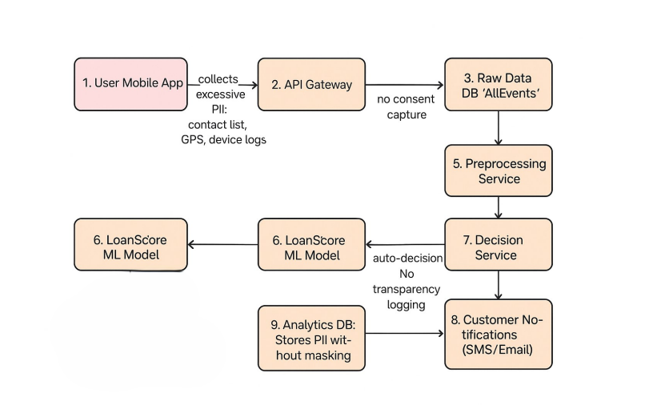
3
5
4
2
1
Corrections:
1 - Implement data minimization at collection: To prevent excessive PII collection that exceeds loan assessment requirements.

2 - Implement consent capture mechanism: To ensure lawful processing of PII before storage in compliance with data protection regulations.

3 - Implement decision transparency logging: To provide audit trails for automated lending decisions and enable customer explanations.

4 - Implement data masking: To protect PII in the Analytics DB from misuse.

5 - Implement decision transparency logging: To provide audit trails for automated lending decisions and enable customer explanation

Data Governance Review Process

My risk identification followed the data lifecycle from collection through processing and storage, examining each stage against classification requirements. At collection, I assessed whether QuickLoan gathered only necessary data—contact lists failed this test, representing excessive collection of third-party personal data without legitimate purpose. This violated data minimization principles under Ghana's Data Protection Act Section 19.

At classification, I categorized collected data by sensitivity: financial information, phone numbers, and device IDs constitute sensitive personal data requiring heightened protection through encryption and access controls. The original system treated all data uniformly, failing to apply stronger safeguards to high-risk information and increasing breach exposure.
During processing, I examined data quality controls and discovered incomplete records with inconsistent formatting entering the ML model. Poor data quality at this lifecycle stage degrades model accuracy and produces unreliable loan decisions. I also identified that proxy variables (contact network size, device type, location) could encode socioeconomic bias, causing the model to learn inequality patterns rather than actual creditworthiness.
Throughout this analysis, classification principles revealed that QuickLoan lacked differentiated handling: sensitive financial data stored alongside non-sensitive metadata, excessive PII collected without consent mechanisms, and no retention policies to limit data lifespan. Each lifecycle stage exposed risks because the system operated without classification-driven controls.

Ensuring Ethical Governance Through LAFR
The Loan Approval Fairness Ratio (LAFR) ensures ethical governance by making algorithmic bias measurable and actionable. LAFR compares approval rates across demographic and socioeconomic groups monthly, triggering investigations when disparities exceed ±10%. This metric operationalizes fairness in three ways.
First, it creates early detection capability—systematic disparities surface quickly rather than accumulating unnoticed until customer complaints emerge. Second, it enables accountability leadership and compliance teams to review LAFR monthly through a governance dashboard, making bias monitoring a routine management responsibility rather than an afterthought. Third, it drives corrective action—threshold breaches trigger investigation into whether disparities reflect legitimate credit risk differences or problematic model behavior requiring retraining.

The grouped bar chart visualization makes disparities interpretable to non-technical stakeholders, ensuring that ethical oversight does not require data science expertise. Unlike vague commitments to "responsible AI," LAFR provides a concrete number tracked alongside business metrics, transforming ethical governance from aspiration into operational requirement and supporting QuickLoan's sustainable growth while maintaining public trust.

